After all of the work we felt these work we felt that our vocabulary is still small

So we downloaded an oxford dictionary of 2016

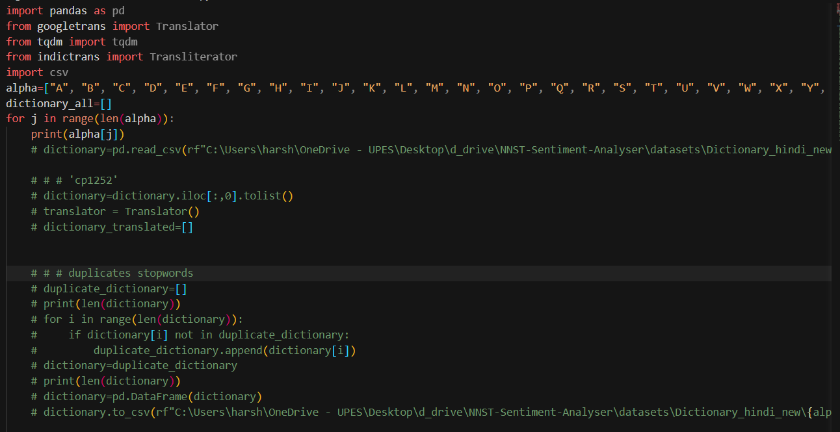

Here we have created a list of all the alphabets and with those we are iterating over each files of the dictionary.

And performing all the previous tasks of generating hindi , hinglish, erroneous words, etc

Translation

Transliteration

Converting multispaced data to one word each row data

And saving it as the adjacency list at the end.